

Master Thesis
in the Master’s program
International Corporate Communication and Media Management
at University of Applied Sciences Neu-Ulm

The Consequences of Social Media Alarmism in Kenya during the COVID 19 Pandemic

Examiner: Prof. Dr. Reisach

Author: Thandiwe Yego (285994)

Declaration
I hereby confirm that the attached master’s thesis is my work and that it has not been used
for other examination purposes; I have named all the sources and auxiliary material used, and
I have marked appropriately quotations used verbatim or which I have given the gist of. I
tolerate the check using anti-plagiarism software.

Place, Ulm, Germany Date 26.07.2022 Signature

Table of Contents
List of Abbreviations used in the Paper 4
List of Tables 5
Abstract 7
Chapter 1: Introduction to the Consequences of Social Media Alarmism in Kenya during the COVID 19 Pandemic 8
1.1 Relevance of the Problem 9
1.2 State of Research and Research Gap 11
1.3 Hypothesis and Research Questions 14
1.4 Procedure/Methods 15
1.1.4 Qualitative Method: In-Depth Interviews 16
1.5 Research Methodology 16
Chapter 2: Theoretical Framework 16
2.1 The Impact of Internet Connectivity in Kenya 17
2.2 Barriers to Internet Access 19
2.2.1 High costs and inadequate infrastructure 19
2.2.2 Digital Literacy 19
2.2.3 Poverty 20
2.2.4 Gender Power Dynamics 20
2.3 Cyber/internet laws in Kenya 21
2.3.1 Online Media Self-Censorship 22
2.4 Social Media Practices and Trends in Kenya 23
2.5 Social Media Use: 24
2.5.1 A Tool in Public Discourse 24
2.5.2 Online Misinformation and Fake News 24
2.6 Social Media Use by Age 26
2.7 Social Media Use by Education Level 30
2.8 Social Media Use by Gender 35
2.9 Social Media Use by Income Level. 38
2.10 Social Media Use by Geo-location 41
2.11 Motivation for use of most popular sites 44
2.12 Analysing the Pandemic of Fear in Kenya 45
2.13 Comparative Analysis Bhutan vs Kenya 47
Chapter 3: Results and Discussions 51
3.1 Analysis of In-depth Expert Interviews and Discussions 51
3.2 Shortcomings and Reflection 62
3.3 Conclusion and Recommendations 64
References 67

List of Abbreviations used in the Paper

WHO- World Health Organization
UNICEF- United Nations International Children’s Emergency Fund
ICT- Information Communications Technology
5G – Fifth Generation
ISPs- Internet Service Providers
NCCC- National Computer and Cybercrime Coordination Committee
NCIC- The National Cohesion and Integration Commission
LSK- The Law Society of Kenya

List of Tables

Table 1. Social Media usage in 2022
Table 2. Social Media Use by age 14-20 Years
Table 3. Table 3 Social media use by age 21-25 Years
Table 4. Social Media Use by age group 26-35 Years
Table 5 Social Media Use by age group 36-45
Table 6. Social Media usage by Primary School education
Table 7. Social Media Usage by High School Education
Table 8. Social Media usage by Undergraduate Education
Table 9. Social Media usage by Postgraduate Education
Table 10. Social Media usage by Females
Table 11. Social Media usage by Males
Table 12. Social Media usage by Low Income Level
Table 13. Social Media usage by Middle Income Level
Table 14. Social Media usage by High Income Level
Table 15. Social Media usage in Urban Areas
Table 16. Social Media usage in Rural Areas
Table 17. Top Social Media Apps for Entertainment
Table 18. Top Social Media Apps for Social Issues
Table 19. Social Media Apps for Work

List of Figures
Figure 1. Adult literacy rates in Africa by region
Figure 2. News sources used by Kenyans
Figure 3. Gaps in Covid 19 information in Africa
Figure 4. Composition of Corona Virus Misinformation
Figure 5 Internet access by type in Kenya 2021
Figure 6. Overview of internet use
Figure 7. Finds Fake News Online
Figure 8. Finds Fake or Incorrect News online
Figure 9. Purposes for Social Media use in Bhutan

Abstract

High African temperatures, drinking bleach or alcohol, and having black skin are just a few of the many dangerous false narratives to prevent the spread of COVID 19 that are propagated on social media. What makes this even more dangerous is the high level of illiteracy in several African countries which leads many to believe this misinformation. Although African governments and different non-governmental organizations have been trying to battle the spread of such fallacies with harsh consequences for those responsible for spreading these rumors, it can be difficult to change the deeply ingrained beliefs of some rural communities. This has only led to more deaths and cases of new infections on the continent.
Design/Approach: This paper uses expert interviews, credible and scientific secondary sources of information which include online articles and academic literature, journals and news articles to test its hypothesis and answer research questions,
Originality: This research paper underwrites already existing scientific works in the years preceding the pandemic to comprehend what has triggered alarmism on social media platforms and its consequent impact on Kenyan society. This argument is particularly crucial because of the fact that social media is central to today’s society and affects all regions of life across the globe and its use is detrimental to either the growth or deterioration of different communities.
Keywords: Covid 19, social media alarmism, crisis management, internet literacy, Whatsapp, Facebook, internet penetration, Gen Z, Millennials, social media bots, algorithm, memes, hashtags, cyber crime

Chapter 1: Introduction to the Consequences of Social Media Alarmism in Kenya during the COVID 19 Pandemic

Compared in scale to the Spanish Influenza of 1918, which claimed approximately 500 million lives across the globe and was deemed the deadliest pandemic in recent history, COVID 19 shook the world with its first outbreak in Wuhan, China in late 2019. But unlike the Spanish Influenza, COVID 19 made its appearance during the age of rapid technological advances and the formidable industry of social media and the internet. The virus proliferated worldwide at an exponential rate and affected different countries around the world, eliciting divergent crisis management responses from each nation.
Despite official warnings and measures provided by the authoritative international health bodies such as the World Health Organization (WHO), some countries were resistant to these directives. Most African nations were at the center of the resistance. “From research which has been conducted by the World Health Organization and various health organizations, alcohol plays a very major role in the killing of the corona virus or any sort of virus.” As reported by Reuters, these were the utterly misleading words of former Nairobi, Kenya Governor Mike Mbuvi Sonko. One myth among many home-spun COVID 19 remedies that have been propagated on social media most particularly in African countries.
African governments have done their best to build credible sources for corona virus information. From daily press briefings (such as in Kenya) to regularly updated online data portals. This paper aims to shed more light on the elements that are responsible for social media alarmism and the drivers behind them. Furthermore, the aim is to explore the repercussions felt in the Kenyan community, what is currently being done to properly address the problem and possible suggestions moving forward. Comparisons with the country of Bhutan, which has handled the pandemic and misinformation more effectively will be made.

1.1 Relevance of the Problem

While increased internet connectivity has played a crucial hand in transforming different sectors of the economy, including agriculture, financial services, health and education, there is a downside to more people having access to the internet during the pandemic. Fake medical notices across the African continent have become common place causing mass panic and even further spread of the virus.
The WHO refers to the global misinformation problem as an "infodemic" and has indicated that fighting its spread requires vast resources, Organizations such as the United Nations International Children’s Emergency Fund (UNICEF) are trying to establish credibility by publishing “myth buster” videos on Twitter that they produced inhouse.
Furthermore, to ensure the mitigation of false information, UNICEF has established a coronavirus information sharing center that encourages the distribution of trustworthy information on prevention, treatment and symptoms of the virus. Despite efforts from popular social media platforms such as Twitter, Facebook and Instagram to delete the daily flood of fake news posts, the internet is an endless rabbit hole and some of these posts are impossible to delete. But what happens when false information is spread by seemingly “trustworthy” organizations? In Ghana for example, in a bid to reassure customers, several bars and restaurants post fake UNICEF notices on their websites
When incorrect advisories are disseminated by trustworthy people or organizations, they are immediately considered as valid, then quickly spread by word of mouth. Bringing it back to Kenya, misinformation about COVID 19 is widespread especially on social media platforms such as Whatsapp. Naturally, this has made managing the pandemic extremely difficult for the country because majority of illiterate rural settlers believe that Kenyans cannot contract the virus due to their dark skin among other fallacies.
The government took swift action by threatening fines and imprisonment for those who spread false COVID 19 information online. The one problem shared between many African countries is that despite increased internet connectivity, the level of illiteracy is still high. As of 2019, only 66.8% of Africa’s aggregate population were literate This shows that there is a large gap in the populations ability to properly interpret information concerning the pandemic hence making it all the more difficult to combat.
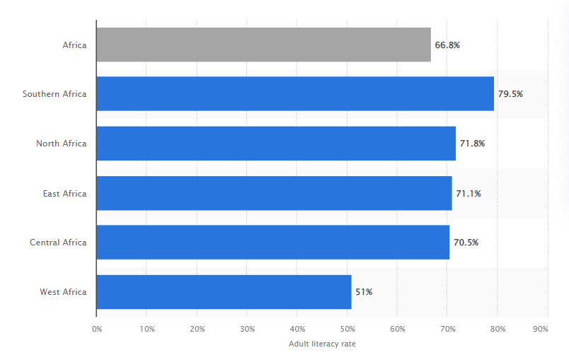
Figure 1. Adult literacy rates in Africa by region
As seen in the figure above, while Southern, North, East and Central Africa have a similar average of literacy, West Africa is trailing behind. This paper has relevance in understanding how socio-economic factors in part, have contributed to social media alarmism and its consequences during the ongoing pandemic. Furthermore, its importance lies in the analysis of attitudes towards COVID 19 in Africa, but specifically Kenya.

1.2 State of Research and Research Gap

Because this paper centers on social media and a global pandemic, it must take into consideration the literature and latest scientific developments in an actively on-going crisis. The unique and novice nature of the COVID 19 virus demands constant updates to research as no countries have yet been successful in completely eradicating it. Being a medical and social phenomenon, as a starting point the outlook of authoritative global health organizations, data banks and credible experts in the field of social media will be taken into account.
An existing report by the Reuters Institute and the Oxford University revealed that greater reliance on social media and other platforms gives people access to a wider range of sources and “alternative facts” some of which are contrary to scientific truths, misleading or just simply “fake news”

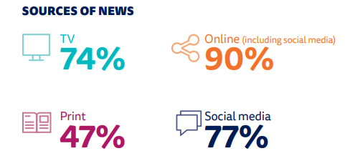
Figure 2. News sources used by Kenyans
Further illustrated in figure 2 above, the Reuters Institute Digital Report shows heavy reliance on social media for news with a whopping 90% getting their news online. The socioeconomic landscape in African countries have been greatly transformed by advancements in internet connectivity. However, these developments have not prevented deeply ingrained cultural beliefs from dominating ideas and beliefs surrounding the pandemic.
A survey from global market research from Ipsos, found that despite a large number of Africans having proper awareness and knowledge of COVID, there are still a few that either don’t believe its fatality or mistrust their governments with proper information.
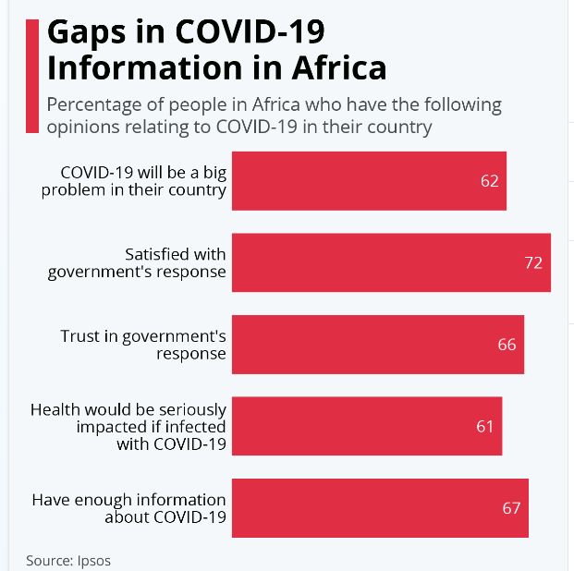
Figure 3. Gaps in Covid 19 information in Africa
.
Only 66% of people trust in their government’s response and another 67% of respondents felt like they have enough information to make educated and informed decisions. 39% of Africans said they felt COVID-19 wouldn’t have a big impact on their health if they were to contract the virus.
The spread of misinformation about COVID-19 is a global problem that needs to be constantly addressed.
On a more global scale, the American Association of Tropical Medicine and Hygiene, formed a team of social scientists, medical doctors, and epidemiologists to collect and review infodemic reports between December 31, 2019.The research was based on 2,311 respondents related to the COVID 19 infodemic in 25 languages from 87 countries.
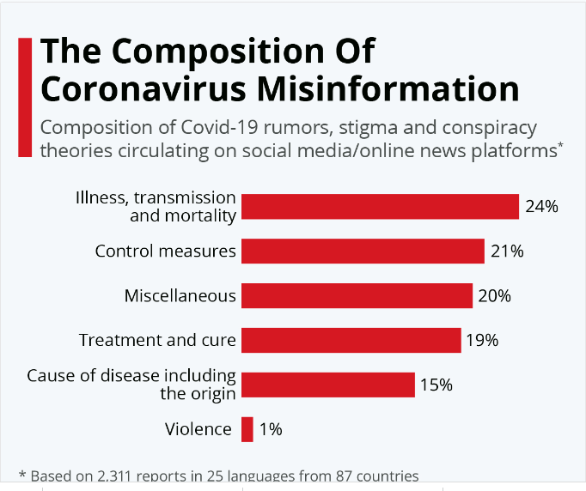
Figure 4. Composition of Corona Virus Misinformation
Seen in the results above, 24% of misinformation was related to illness, transmission, and mortality; 21% to control interventions; 19% to treatment and cure; 15% to the cause of disease including the origin; 1% to violence; and 20% to miscellaneous .Although there has been extensive research on the virus and its global impact in all areas of daily life, little exploration has been done on social media alarmism in Kenya, how successful the government has been at managing the problem and how the spread of the virus has been amplified by misinformation.

1.3 Hypothesis and Research Questions

The objective of this paper is applied through qualitative research methods to understand the link between social media alarmism and its consequent impact in Kenya.
More specifically, the aim is to answer the following research questions:
- How do socio economic factors contribute to internet literacy and access?
- What are the main drivers of misinformation and social media alarmism?
- To what extent and how does social media alarmism increase the spread of the virus?
- Has the government been successful at combating the spread of fake news?
Hypothesis
- The younger generation of social media users are more responsible for the spread of COVID 19 misinformation online than older users
- Government efforts had no positive effect in reversing the spread of COVID 19 misinformation

1.4 Procedure/Methods

Considering the extremely wide scope of the topic, this paper will be narrowed down to focus on Kenya specifically with comparison of different systems in the country of Bhutan. The paper will explore the countries socio economic landscape as well as internet penetration. There will be reference to Kenyan government publications, news articles, articles published in academic and scientific journals and up to date published print literature on the subject.
.
In the first chapter, the paper will be solely focused on the theoretical framework defining the features of internet penetration in Africa and Kenya specifically, the laws and regulations surrounding internet usage and socio-economic traits of the researched country. This chapter will utilize academic and scientific journals, online news articles and government websites as the key sources.
The second chapter is in direct correlation with the first, as this chapter will examine the results of the research methodology used in an in-depth analysis of social media in Kenya and the alarmism caused on various social media platforms followed by their consequences and comparisons with other countries. Furthermore, I will mainly give sound and objective reasoning concerning the research methods used.
The third and final chapter will be dedicated to analysis of in-depth interviews and discussions, shortcomings and reflection and finally the conclusion and recommendations.

1.1.4 Qualitative Method: In-Depth Interviews

This paper will utilize insights from 3 experts in the field of journalism and social media. Namely Gloria Aradi (Freelance journalist), Fahmo Mohammed (CEO at Studio 63 Ltd) and Killiad Msafiri (Standard Media Group). In depth questions will be asked about their observations on social media regarding the spread of fake news and government/ private sector attempts to curb misinformation online. The interviews will be presented in video and audio format. Each of these experts are stationed in different parts of the country, both urban and rural and will be able to give invaluable firsthand insight from their bases of operation.

1.5 Research Methodology

The research methodology will incorporate qualitative research methods through in-depth analysis and review of secondary information in the form of web materials, news articles, data banks, government and scholarly publications. Furthermore, the research will include interviews from expert sources from the social media and journalism field. Since the plans travel to Kenya were thwarted by personal health concerns, the expert interviews will be conducted on video and audio. The goal of the research is to understand dynamics of social media alarmism, analyze the primary and secondary data and integrate the empirical research results with insights from various government, scientific and academic observations and recommendations.

Chapter 2: Theoretical Framework

When looking at the research question of social media alarmism in Kenya during the pandemic, it is crucial to examine the socio-economic state of the country. Not only do socio economic factors directly affect technological advancement and internet access, they also have a large role to play in education and (digital) literacy levels. As argued in previous chapters of this paper, lack of internet literacy and low levels of education, play a substantial role in the spread of misinformation and social media alarmism. Lack of digital literacy results in the inability to discern falsehood from truth therefore increasing the chances of spreading fake news. This chapter will focus on analyzing internet reach in Kenya and the consequent cyber-crime laws, levels of (digital) literacy and the Kenyan social media landscape.

The Impact of Internet Connectivity in Kenya

Increased access to mobile broadband and the spread of low-budget smart phones has resulted in the rapid extension of mobile technology and mobile internet in the past few years. It has been found that more households in Africa have access to mobile phones rather than clean water and electricity. Kenya in particular, has taken the lead ahead of other African countries in mobile internet advancements facilitated by greater access to fiber optic cable connections to households and mobile broadband.
Not surprisingly, most people using their mobile phones do so to connect to the internet. The figure below further illustrates the statistics on Kenyan’s preferred device for accessing the internet at home. Mobile and smartphone connections are leading at 60% (in a sample group consisting of 1,049 respondents) attributed to the factors already listed previously in the chapter.

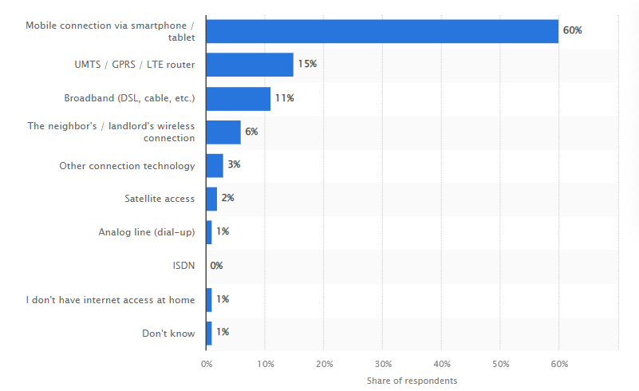
Figure 5 Internet access by type in Kenya 2021
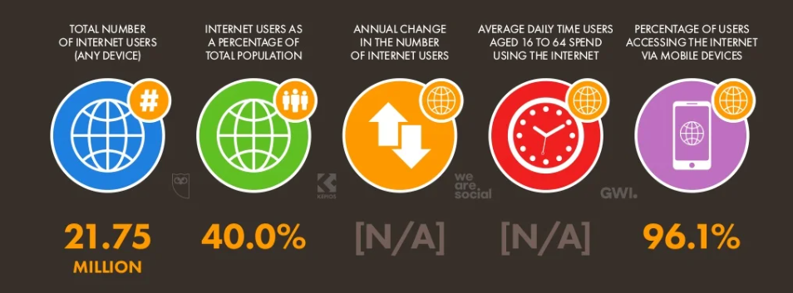
Figure 6. Overview of internet use
As shown in the figure above, in spite of significantly high mobile phone penetration and stronger money mobile usage, only a meager 40% of Kenyans were using the internet in
2021. In the next chapter, the barriers to internet access and efforts to resolve them by both the government and private sectors will be evaluated.

2.2 Barriers to Internet Access

2.2.1 High costs and inadequate infrastructure

It has already been concluded that the internet is on an upward projectile in terms of service availability in rural areas and mobile device access. However, high costs are still a concern and inadequate infrastructure limits the speed and quality of connections. Average connection speeds appear to have declined, from 10.11 Mbps in 2017-18, to 7.62 Mbps in 2018-19 according to Cable, a telecommunications company based in the United Kingdom. Kenya now positions third in Africa, after Madagascar and South Africa. In light of these shortcomings affecting internet speed, the Kenyan government has prioritized the expansion of Information Communication Technologies (ICT) capacity, with internet connectivity as a vital pillar,
In the private sector, Safaricom, Kenya’s largest telecoms company, launched the country’s first fifth-generation (5G) mobile internet services targeting major urban centers in 2020, making it the first operator to offer commercial and highspeed services in the region. The outbreak of COVID 19 has forced many educational institutions and businesses to move their operations online, which has in turn pushed Internet Service Providers (ISPs) to improve bandwidth and meet demand. This means that now more than ever, effective internet services are crucial in the country, not only for business purposes but in many spheres of entertainment and news gathering.

2.2.2 Digital Literacy

One of the other major challenges faced in Kenya is digital literacy. Although as earlier noted that mobile penetration is on the rise, the number of people able use this technology is considerably low. Urban areas have a higher penetration of mobile phones than in rural areas, and naturally, one of the limitations in rural areas is literacy levels. Little education means that many older individuals struggle with this technology and are often wary of them. The government launched a Digital Literacy Program but was faced with the challenge of illiteracy, where the devices were too complicated for some teachers to use and technical support from experts was low.

2.2.3 Poverty

Poverty is a widespread problem in the whole country, but rural areas are more affected by extremely low-income levels. As a result, due to the fact that they do not have much disposable income, the demand for many services is lower in rural areas than in urban areas. In communities that lack the most basic of amenities, digital services may be outweighed by basic needs. The costs of implementing infrastructure to fuel those networks are extremely high in spite of lower purchasing power in rural areas.

2.2.4 Gender Power Dynamics

Not surprisingly, the gender power dynamics in rural communities dictate that fewer women have access to mobile phones resulting in low participation for women. In most households, there is often 1 mobile phone owned by the husband. Encouragingly, this trend is rapidly changing with an increased influx of cheap smart phones made in China.
Affordable internet and access in rural areas has become the main focus for the government particularly due to the digitization of many government services that were previously offered face-to-face at “Huduma Centers”


2.3 Cyber/internet laws in Kenya

Internet laws and regulations have been a topic of controversy because it is claimed that internet censorship sometimes lacks fairness and balance.
Aden Duale, a parliamentarian, in March 2021 proposed an amendment to the Cyber Crimes Act. This bill imposed a 20 million Kenya Shillings fine or 25-year jail term for individuals circulating pornography, terrorism, extremist religious beliefs and cult activities. In a bid to strengthen the bill, the National Computer and Cybercrime Coordination Committee (NCCC) was given the power to render suspicious websites inaccessible within the country. However, the committee is a government appointed body that lacks both oversight and transparency mechanisms.
The National Cohesion and Integration Commission (NCIC), 2008 states that a media house can be fined up to 1 million Kenya shillings for publishing hate speech and can also invoke online content to be taken down. Hate speech in this case is defined as “words intended to incite feelings of contempt, hatred, hostility, violence or discrimination against any person, group or community on the basis of ethnicity or race.”
Kenyan journalists saw the signing of the Cyber Crimes act bill as witch-hunt and a threat to press freedom.

2.3.1 Online Media Self-Censorship

The media plays the role of society’s watchdog or the 5th estate. Therefore, they are expected to display complete objectivity and accountability when reporting the news. However, due to certain factors, this is not always the case and can lead to tension between media houses and the state. So, what happens when the media goes against codes of conduct? Online journalist arrests in Kenya, which are often seen as a breach of press freedom, sparked controversy and prompted concerns about self-censorship by the press. The financial survival of media houses is highly dependent on government advertising meaning journalists must display self-censorship to maintain this symbiotic relationship.
In March 2020, bloggers were arrested under the Computer Misuse and Cyber Crimes Act (2018), for allegedly posting alarming or fake news about COVID 19. Herein comes the tension. As a rebuttal to these arrests, The Law Society of Kenya (LSK) made a move in court against state demanding that the bloggers be released. However, the National Police Service, stated that freedom of expression is not an absolute right as argued by the LSK. The governments motives were to protect citizens from false and misleading information that would consequently lead to mass panic therefore thwarting its efforts to care for its people. Was the government justified in its actions? In what is clearly a grey area, the LSK responded by arguing that the arrest and prosecution of bloggers would have a “chilling” effect on independent bloggers and activists, discouraging them from publishing information in fear of abuse of Ministry of Health COVID 19 guidelines. Despite these attacks encouraging self-censorship online, some may see them as a threat to freedom of press.

2.4 Social Media Practices and Trends in Kenya



Highlights of Social Media Usage
Most Kenyans use |  | Top 3 Motivations for using social media | Types of social media accounts followed
Facebook | 89.6 % | 50 %- Acquiring information, news, knowledge, exploration | 50.4% Family and friends
Whatsapp | 93.5 % | 33.8 % Entertainment and pleasure | 33.4% Influencers and experts
Instagram | 69.4% | 57.0 % Social Interactions | 31.7% journalists and news companies
Twitter | 60% | 38.2% Sharing Opinions
Table 1 Social Media usage in 2022
As the statistics show above, most Kenyans utilize social media networks mostly for the purposes of acquiring news and information (50%) as well as social interaction (57.0). They also have a higher tendency to follow family, friends (50.4%) and news companies (31.7%) Facebook (89.6%) and Whatsapp (93.5%) are the most used social platforms and this could be due to the fact that these platforms foster discussions on social issues. Later in this paper, we will make a sound correlation between these statistics and how misinformation about the COVID 19 pandemic is disseminated online.

2.5 Social Media Use:

2.5.1 A Tool in Public Discourse

In recent years, social media had become a very crucial part in Kenyan public address, being an important part of socio-economic, cultural, and political debates while at the same time enabling online discussions. In spite of this fact, engagement in social media dialogue is characterized by intolerance for differences in opinions and ideas. It is common place for Kenyans to engage in robust online debates, such as the COVID 19 pandemic, surrounding modern issues in society on social media.

2.5.2 Online Misinformation and Fake News

The creation and dissemination of fake news on social media has become common place and nearly impossible to curb. The lack of tools for verifying photos, videos, or sources on individuals’ feeds has only made the dissemination of falsehoods much worse. It can be argued that most people are not keen enough to check the credibility of sources before publishing and sharing information which leads to fake news spreading quickly or “going viral”. An emerging trend is the creation of artificial social media profiles or bots that are used to spread misinformation online. These profiles are very easy to create and on platforms like Twitter, they are known for tweeting fake news items, and engaging on the posts of authentic users. Content with more engagement is prioritized by Twitter’s deep learning algorithm making it easier for social media bots to spread fake news. Even though most social media sites have been increasing their efforts to fight the spread of fake news on their social networking sites and apps this does not stop individuals from propagating false and inaccurate information.

.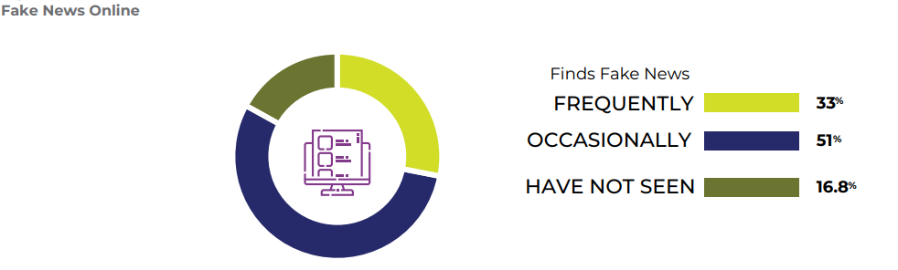
Figure 7 Finds Fake News Online
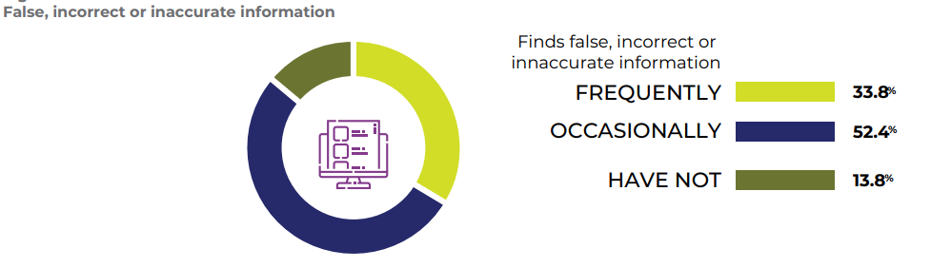
Figure 8 Finds Fake or Incorrect News online

Figure 5 shows that 35% of Kenyans say that they have come across fake news on social media and are likely to have shared the misinformation, with only 16.8 % reporting that they have not come across any false news. Figure 6 shows that 33.8% of Kenyans have come across false, incorrect or misleading information on social media while 13.8% have not. The reasoning in the statistics above collected by SIMElab can be attributed to the fact that bots continue to operate freely on social media . Furthermore, most Kenyans might trust the news because the sender is a person, they rely on to send accurate information such as family or friends. This can further be re-enforced by statistics from table 1 that shows 50.4% of Kenyans follow social media accounts of family and friends.

2.6 Social Media Use by Age
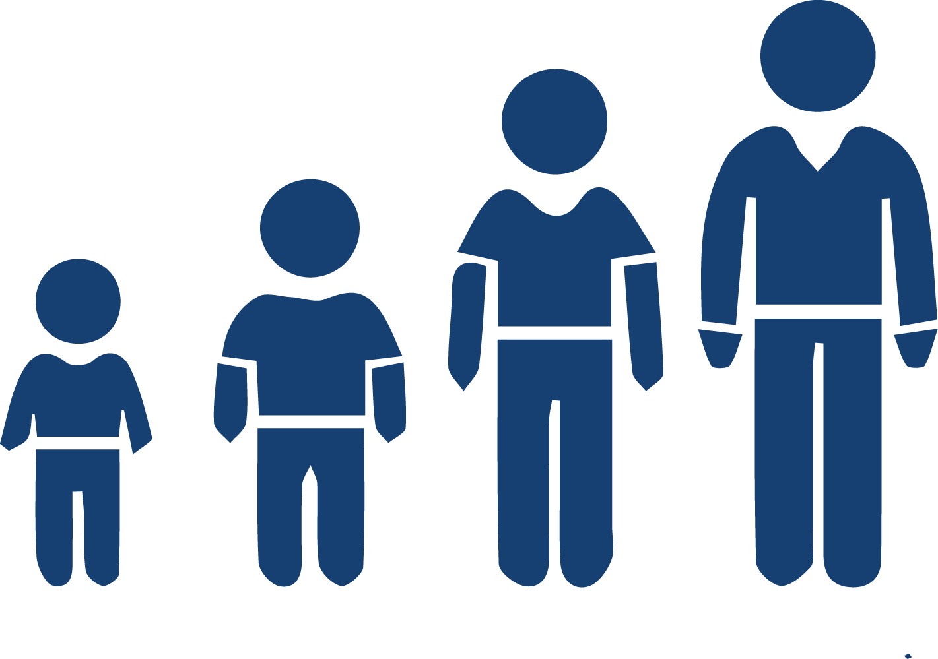
The social media platform landscape is constantly changing with new applications emerging for different uses such as socialization, business and educational purposes. With that said, certain platforms are falling out of favor with some groups, while newer ones pick up traction. Due to the fact that the number of social media platforms is vast, this section will only analyze the relevant aspects in each table study. The survey results used for these table analyses (table 2 to table 20) were obtained from the social media Lab Africa, an interdisciplinary Center for research in Big Data and Social Media Analytics housed at United States International University Africa. It was carried out in 2020, with a sample of 9.728 participants from 17 counties.

Usage by age | Summary of Quantitative Usage | Type of Social Used by highest to lowest
14-20 Years | 22.3% | Snapchat
 | 20.8% | TikTok
 | 19.4% | Pinterest
 | 15.5% | Instagram
 | 13.3% | Whatsapp
 | 13.1% | Facebook

Consequences | Reflection
From the data above, it can be deduced that the younger generation, also known as “Generation Z” are moving away from Facebook in favor of video and picture sharing platforms such as Snapchat, TikTok and Pinterest. Snapchat and TikTok being the most popular, with 22.3% and 20.8% respectively. | The Covid 19 pandemic resulted in global lockdowns forcing everyone to remain in doors. Video sharing platforms picked up more traction than ever, and became the most popular applications in the entertainment of “Gen Z” In my evaluation, as presented in table 1, this age group may fall into the 33.8% of Kenyans that use social media mainly for entertainment and pleasure.
Table 2 Social Media Use by age 14-20 Years

Usage by Age | Summary of Quantitative Usage | Type of Media Used Highest to Lowest
21-25 Years | 45.1% | Instagram
 | 44.7% | Snapchat
 | 44.5% | Telegram
 | 41.0% | Youtube
 | 40.3% | Twitter
 | 37. 8% | Whatsapp

Consequences | Reflection
This age group, which can still be considered “Gen Z” is also drawn to video and picture sharing social media apps with Instagram and Snapchat being the most popular at 45.1% and 44.7% respectively. Messaging apps such as Twitter and Telegram are at the lower end of the spectrum but still popular at 40.3% and 40.3% respectively. | Although this age group is still interested in entertainment and social interaction through video and picture sharing apps, they also show interest in using apps such as Twitter and Whatsapp. During the pandemic, information and news has been spread through Twitter and messaging apps such as Telegram and Whatsapp. They also been important tools in sharing opinions. They may also find social media as a reliable source for news on the pandemic and other social issues.
Table 3 Social media use by age 21-25 Years

Usage by Age | Summary of Quantitative Usage | Type of Media Used Highest to Lowest
26-35 Years | 39.2 % | LinkedIn
 | 32.8% | Twitter
 | 31.3% | Facebook Messenger
 | 30.4% | Facebook
 | 28.8% | Instagram

Consequences | Reflection
In stark contrast, this age group, also referred to as Millennials, has more interest in professional social media sites rather than video and picturing sites. LinkedIn has the most popular usage at 32.9% and Skype at 38.5%. Instagram is among the lowest at 28.8%. | Individuals in this age group are more interested in professional networks and establishing their careers hence the higher involvement in sites such as LinkedIn. Furthermore, their interest in acquiring news and sharing information online may very well outweigh their needs for entertainment and social interaction.
Table 4 Social Media Use by age group 26-35 Years
Usage by Age | Summary of Quantitative Usage | Type of Media Used Highest to Lowest
36-45 Years | 13.1% | Facebook
 | 13.0% | Whatsapp/Skype
 | 12.3% | LinkedIn
 | 11.6% | Twitter
 | 8.2% | Instagram
 | 6.7% | Snapchat

Consequences | Reflection
In this age group there is very low interest in picture and video sharing platforms. Instagram is at only 8.2% while Snapchat is at a measly 6.7%. Facebook and Whatsapp/Skype have considerably higher interest at 13.1% and 13% respectively. | These numbers could be attributed to the possibility that individuals in this group are in the employed working class and mostly engage in networks such as Whatsapp, Skype and Facebook to maintain professional networks and obtain news and information. They have little interest in video and photo sharing apps because they have more pressing priorities such as their careers.
Table 5 Social Media Use by age group 36-45


2.7 Social Media Use by Education Level

As distinguished in previous chapters, education plays a vital role in how people interact with information disseminated on social media and their capabilities of understanding these technologies in the first place. If an individual comes across certain information online, one must ponder if they are educated and informed enough to be able to question the credibility of both the information and the source, Previous sections of this paper have already established that younger people, those of primary to university education consider social media as a reliable source of information. In the following table analysis, we will study which platforms are most popular among different levels of education and for what reasons.
Usage by Education Level | Summary of Quantitative Usage | Type of Media Used Highest to Lowest
Primary School | 7.0% | Facebook
 | 6.8% | Whatsapp
 | 4.9% | Youtube
 | 4.4% | Snapchat
 | 3.6% | Twitter
 | 2.7% | LinkedIn

Consequences | Reflection
Social interaction apps such as Facebook and Whatsapp are the highest used among primary school students, assumedly between the ages of 10 and 15 years old with 7.0% and 6.8% respectively, although relatively low. Sites such as Twitter and LinkedIn are the lowest at 3.6% and 2.7% | It is most common for younger students to be more interested in social interaction therefore the usage of Whatsapp and Facebook. However, it is advised that Kenyan schools seek to limit all non-educational, entertainment use of internet, including social networking activities through the internet tools that block access to these sites hence the low numbers. Sites such as Twitter and LinkedIn are low in usage because primary school students have little to no interest in public discourse or professional networking.
Table 6. Social Media usage by Primary School education
Usage by Education Level | Summary of Quantitative Usage | Type of Media Used Highest to Lowest
High School | 27.5% | Facebook
 | 26.7% | Whatsapp
 | 24.1% | Youtube
 | 22.8% | Facebook Messenger
 | 22.7% | Snapchat
 | 14.2% | Skype
 | 12.8% | LinkedIn

Consequences | Reflection
Much like the primary school students, high school students have little interest for the use of professional networking sites such as Skype and LinkedIn which come in at 14.2% and 12.8% respectively. On the contrary, perhaps because they have a higher level of autonomy than primary school students, their use of social networking apps Facebook (27.5%) and Whatsapp (26.7%) is considerably high. | High school students are in their late teens and therefore develop much more interest in connecting with friends and sharing their lives online, and watching movies or videos on Youtube. It is at this point where there less parental control and trust of high school students to understand and navigate social media dynamics. However, they still do not require professional networking sites as they are yet to establish career goals.
Table 7. Social Media Usage by High School Education
Usage by Education Level | Summary of Quantitative Usage | Type of Media Used Highest to Lowest
Undergraduate | 41.4% | LinkedIn
 | 32.5% | Skype
 | 31.5% | Telegram
 | 30.4% | Twitter/Snapchat
 | 30% | Instagram
 | 24.9% | Facebook Messenger

Consequences | Reflection
Undergraduates have a particularly high usage of professional development and networking sites with LinkedIn at 41.4% and Skype 32.5%. Their presence on social networking sites such as Instagram (30%) and Snapchat/Twitter (30.4%) is also considerably high. | It is at this stage that students are extremely active in preparing for their chosen career paths and therefore they seek to build and maintain professional relationships on sites such as LinkedIn. They have already begun to form their views on political and social issues and this explains their high presence on Twitter, a space where they can engage in public discourse. At the same time, they still have a desire to entertain themselves, maintain interaction with friends and possibly family on sites such as Instagram and Snapchat.
Table 8. Social Media usage by Undergraduate Education
Usage by Education Level | Summary of Quantitative Usage | Type of Media Used Highest to Lowest
Postgraduate | 17.9% | Skype
 | 12.6% | LinkedIn
 | 9.5% | Twitter
 | 7.6% | Instagram
 | 7.5% | Snapchat

Consequences | Reflection
With postgraduate students Skype is the most used social media (14.9%) followed by LinkedIn (12.6%) and Twitter (9.5%). | The use of professional networks such as Skype and LinkedIn suggest that postgraduate students are mostly interested in maintaining and building professional relationships. They may also use these sites for work related purposes. The usage of social networking apps can be seen as low. meaning professional priorities take precedence.
Table 9. Social Media usage by Postgraduate Education

2.8 Social Media Use by Gender

As previously mentioned in section 2.2.4, gender power dynamics have a role to play in barriers to internet access. Women have considerably lower access to mobile devices but this is mostly typical in rural areas of the country. Other factors will be taken into account in the analysis below.

Usage by Gender | Summary of Quantitative Usage | Type of Media Used Highest to Lowest
Female | 61.9% | Snapchat
 | 53.6% | TikTok
 | 50.4% | Pinterest
 | 45.4% | Snapchat
 | 44.8% | Instagram
 | 44.6% | Facebook
 | 33.8% | Telegram

Consequences | Reflection
The female respondents have a considerably high usage of video and picture sharing apps, Snapchat (61.9%), TikTok (53.6%), and Pinterest (50.4%) | Women are often characterized by their more expressive qualities and penchant for sharing their interests and personal photos/videos, hence the higher usage of Snapchat and TikTok. Furthermore, they tend to be more creative and have an interest in “do it yourself” projects and arts and crafts, which is highly hosted on Pinterest.
Table 10. Social Media usage by Females

Usage by Gender | Summary of Quantitative Usage | Type of Media Used Highest to Lowest
Male | 66.1% | Telegram
 | 62.1% | Skype
 | 61.6% | LinkedIn
 | 59.5% | Twitter
 | 55.3 | Facebook
 | 55.1% | Instagram
 | 37.9% | Snapchat

Consequences | Reflection
The male respondents in contrast to the female, have a higher presence on Telegram (66.1%), Skype (62.1%) and LinkedIn (61.6%) | This could be as a result of males being more involved in keeping up with professional networks on sites such as LinkedIn, Telegram and Skype and engaging in public discourse on politics, sports social issues and news on Twitter.
Table 11. Social Media usage by Males

2.9 Social Media Use by Income Level.


Usage by Income Level | Summary of Quantitative Usage | Type of Media Used Highest to Lowest
Low Income | 33.9% | Facebook
 | 24.1% | Whatsapp
 | 16.5% | Youtube
 | 15.6% | Twitter
 | 14.9% | Instagram
 | 11.5% | Facebook Messenger
 | 11.3% | Skype
 | 4.7% | LinkedIn

Consequences | Reflection
People who reside in informal settlements or the low-income residential areas use Facebook (33.9%), WhatsApp (24.1%), and Vimeo (19.2%) as their social media platforms of preference. | Nairobi, the urban center in Kenya is home to one of the biggest slums in the world and houses most low-income earners in informal settlements. Mobile service networks in the country such as Safaricom, offer a variety of mobile data offers that support the use of low data apps such as Facebook, Whatsapp and Youtube. Their main uses of these apps are for social interaction and entertainment. Individuals in this group have the lowest use of social media in comparison to others.
Table 12. Social Media usage by Low Income Level
Usage by Income Level | Summary of Quantitative Usage | Type of Media Used Highest to Lowest
Middle Income | 48.6% | Telegram
 | 48.4% | Skype
 | 44.1% | Instagram
 | 42.3% | Youtube
 | 40.1% | LinkedIn
 | 39.4% | Whatsapp

Consequences | Reflection
The middle-income residents residing in Nairobi mostly use Telegram (48.6%), Skype (48.4%), and TikTok (45.0%) | Middle income earners are seen to have more interest in engaging in social media for professional purposes as they mostly have white collar jobs. Furthermore, they have the financial power to afford internet bundles or more costly home WI-FI connections hence regular use of high resource demanding apps and sites.
Table 13. Social Media usage by Middle Income Level
Usage by Income Level | Summary of Quantitative Usage | Type of Media Used Highest to Lowest
High Income | 55.2% | LinkedIn
 | 50.8% | Snapchat
 | 48.6% | Pinterest
 | 46.3% | TikTok
 | 44.8% | Twitter
 | 44.7% | Facebook Messenger
 | 41.2% | Youtube
 | 41.0% | Instagram
 | 36.4% | Whatsapp

Consequences | Reflection
The high-income Nairobi residents mostly use LinkedIn (55.2%), Snapchat (50.8%) and Pinterest (48.6%) | Similar to the middle-income residents, this group of individuals are more likely to spend their time on professional networks They also most likely have a higher disposable income to spend on high-speed WI-FI and internet bundles.
Table 14. Social Media usage by High Income Level

2.10 Social Media Use by Geo-location


Usage by Geo-Location | Summary of Quantitative Usage | Type of Media Used Highest to Lowest
Urban | 67.9% | TikTok
 | 63.4% | Pinterest
 | 62.9% | Snapchat
 | 61.9% | LinkedIn
 | 60.5% | Twitter
 | 59.6% | Skype
 | 58.9% | Instagram
 | 57.6% | Youtube
 | 55.8% | Whatsapp
 | 55.5% | Facebook

Consequences | Reflection
Majority of Kenyans in urban areas use TikTok (67.9%), Pinterest (63.4%) and Snapchat (62.9%) | Residents in urban areas spend more time on these platforms due to adequate technological infrastructure which support the use of high resource demanding social media sites and apps.
Table 15. Social Media usage in Urban Areas

Usage by Geo-Location | Summary of Quantitative Usage | Type of Media Used Highest to Lowest
Rural | 45.3% | Facebook Messenger
 | 44.5% | Facebook
 | 44.2% | Whatsapp
 | 42.4% | Youtube
 | 41.1% | Instagram
 | 38.1% | LinkedIn
 | 37.1% | Snapchat

Consequences | Reflection
Rural residents have a much higher use of Facebook Messenger (43.3%). Facebook (44.5%) and Whatsapp (44.2%) | Contrary to the urban areas, as reflected in section 2.2.1 of this paper, inadequate infrastructure limits the speed and quality of connection in rural areas which limits access to high resource demanding social media apps and sites. Furthermore, the use of WhatsApp, and YouTube in these areas could be credited to being complementary  services offered by the mobile service providers in the country.
Table 16. Social Media usage in Rural Areas

2.11 Motivation for use of most popular sites

In the following tables, this paper aims to reveal the motivation for use of the most popular social media sites. These figures, will give more insight into the demographic data for social media use given above.
Most used Social Media apps for Entertainment | Summary of Quantitative Usage
Youtube | 56%
Instagram | 27%
Snapchat | 11%
Table 17. Top Social Media Apps for Entertainment
Most used Social Media apps for Social Issues/Politics | Summary of Quantitative Usage
Whatsapp | 80%
Facebook | 64%
Facebook Messenger | 30%
Twitter | 35%
Table 18. Top Social Media Apps for Social Issues
Most used Social Media apps for Work | Summary of Quantitative Usage
LinkedIn | 14%
Skype | 7%
Table 19. Social Media Apps for Work

2.12 Analysing the Pandemic of Fear in Kenya

To date, COVID 19 is still the most feared virus in Kenya. The news has consistently broadcast reports of stigma against those who are suspected to have the virus, which has naturally led to low turnout for mass testing in the country. Worsening the situation even further, there has been a lot of discrimination against Chinese nationals in rural areas, with residents believing that the virus was brought by the Chinese and will infect their people. Many fear the social stigma attached to COVID 19 even more than the virus itself. Stigma, rumors and misinformation, have played a big role in fueling fear and how people seek treatment. Misconceptions and rumors also play a role in shaping public opinion and as already established in previous chapters, they have widely spread in African countries. For instance, in Tanzania, the late president Magufuli caused debate by advising people to pray against the virus, which he labelled as “satanic” and one that could only be cured by “divine intervention” It will later in this paper be revealed that especially among young people, COVID-19 has become the main topic of discussion on social media platforms that are packed with misinformation. An increasing number of satirical images also known as memes have been created making fun at how the public has responded to the pandemic, with many posters reflective on how family and friends no longer share their health status due the anxiety that any illness would make them become alleged as COVID-19 carriers. Furthermore, the pandemic of fear has also affected healthcare facilities especially in rural areas where a simple temperature check became the standard criteria for admitting patients with the dreaded COVID 19 virus in isolation wards. In states of assumed panic, nurses were reported to have been sending any patients with a temperature of above 37 degrees Celsius to isolation wards, regardless of the fact there were no accompanying symptoms typical of COVID. A high fever is not determinant of COVID infection but it could indicate the presence of several other diseases. Not surprisingly, people who could be suffering from these other diseases have been unnecessarily held in quarantine facilities, only to discover their test results coming back negative. As an expected consequence, this cause for false panic has adversely impacted their health-seeking behaviors and those of many others who hear their stories. Health facilities across the country are recording a substantial drop in the number of patients showing respiratory conditions. Of course, international and national media alike, have done extensive coverage on how physical distance and the national ban of travel during curfew hours have resulted in deaths of people, including women in labor, not being able to access appropriate healthcare. Despite remaining open, patients were prevented from visiting hospitals due to fear of being stigmatized along with a lack of medicine and staff during the lockdown. Kenya is known to have one of the worst maternal mortality rates globally. Numbers are not yet available on the consequences of the novel curfew, but experts believe the number of babies and mothers who do not survive childbirth has increased pointedly since it was imposed mid-March. Further fanning the flames of fear of breaking the curfew, the Kenyan police force, especially in low-income areas regularly enforced harsh beatings. The beatings were dished out mercilessly in spite their reasons which could have included seeking emergency medical attention. It was common place for this to take place all over the country, and with government officials having little to no health literacy, the act on enforcing laws became a super spreader itself. No masks were being worn by these officials and they were not observing social distancing rules making it all the more difficult to combat the virus.

2.13 Comparative Analysis Bhutan vs Kenya

Country Background
Located in the Eastern Himalayas, in South Asia and boarding China and India, Bhutan is a relatively small landlocked country. The country had a population of 7771,608 people in the year 2000. Its government is a democratic constitutional monarchy and its religion is Vajrayana Buddhism.
Inadequacies in Healthcare, Preparedness, Public Trust
The world has long been in admiration of Bhutan’s healthcare system, where its citizens receive access to free medical health care. Its constitution emphasizes that “the State shall provide free access to basic public health services in both modern and traditional medicines.” Their exemplary healthcare system and hospital capacity to tackle a global pandemic, is one of the reasons they were so successful in limiting the spread of the virus. Kenya, in comparison as a country where access to proper and affordable healthcare is a challenge especially in rural and low-income areas, was not able to mitigate the virus as successfully.
The Kenya Healthcare Federation highlighted the key challenges facing the healthcare system in Kenya, namely limited access to healthcare facilities, lack of sufficient personnel and know-how to address medical needs, and poor infrastructure where most hospitals do not have the appropriate amenities to handle medical challenges such as the Corona virus. In addition to their outstanding healthcare system, Bhutan had the ability to respond to the pandemic swiftly and decisively, immediately implementing crucial public health strategies such as testing, identifying, training, quarantining and treating COVID cases. Health personnel was increased and healthcare and testing facilities were set up to ensure that basic health services would be delivered during lockdowns. It can be argued that their transparency and lack of hesitancy from the start in communicating about the virus left no room for the proliferation of misinformation as people searched for answers. Kenya’s policy approach became increasingly harsher as the virus entered the country.
President Uhuru Kenyatta on February 28 2020, formed a new board to spearhead the response to COVID-19. Chaired by the Cabinet Secretary for Health, he was tasked with managing the country’s COVID-19 preparedness, prevention, and response in particular, The committee was expected to manage surveillance at points of entry into the country and the preparation of quarantine facilities, medical supplies, protective gear and medical professionals. Kenya has been heavily reliant on external funding for its coronavirus response. However, there have been allegations that the finances had been misappropriated and not allocated ethically. Now more than ever, citizen trust and compliance with health directives such as lockdowns and curfews are of crucial importance. Allegations of corruption and lack of transparency only resulted in Kenyans undermining government responses to the pandemic making them susceptible to misinformation spread on the internet.
The acceptance of vaccinations in Bhutan was highly successful with their leaders spearheading the efforts. The people of Bhutan, unlike in Kenya as will later be revealed, have deep trust in their governance. The King of Bhutan displayed his genuine concern for his people during his travels all over the country to support and guide national efforts against the virus, and also by attending the launching of the nationwide COVID-19 vaccination program. On the opposite side of the spectrum, Kenyans were extremely divided over taking the vaccine doses, due to misinformation and lack of trust between the public and the government. Unlike the government officials in Bhutan who set the precedent for vaccinations, Kenyan officials were not the first to lead by example and therefore majority of Kenyans based in the capital city of Nairobi showed expressed skepticism and doubt. This mistrust in the government and its directives only served the increased spread of misinformation and rumors among Kenyans.

Social Media Landscape in Bhutan

Similarly to Kenyans, most citizens of Bhutan engage on social media as consumers and producers of content, disseminating information, education, interaction, business and entertainment.
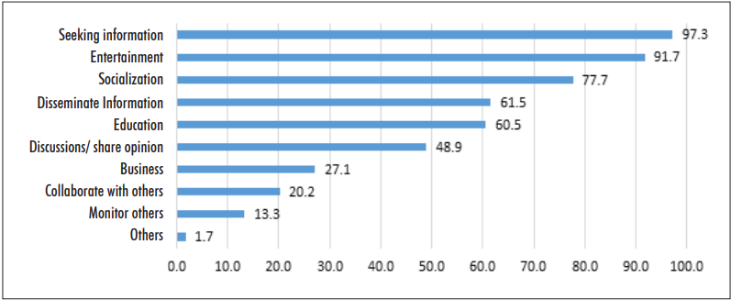
Figure 9. Purposes for Social Media use in Bhutan
As displayed in the figure above, the seeking of information, entertainment, socialization, disseminating information and education are the top five drivers of social media use in Bhutan. Social media has mainly been used in the country during the pandemic for getting news, entertainment and social interaction. Not unlike Kenya, social media in Bhutan was awash with fake news and misinformation. But one marked difference between the two countries in handling the problem was that the Prime Minister’s office and Ministry of Health utilized their Facebook pages extensively to make up to date announcements, communicate with the public and raise awareness to deter fake news and misinformation. Citizens were allowed to ask regarding COVID 19 vaccination plans and engage in transparent dialogue. As already previously observed, the Kenyan governments vaccination plans were shrouded in allegations of corruption and mystery. While there are laws in place to tackle cybercrimes as seen in chapter 2.3, the Kenyan government has not been very harsh about enforcing them. More light will be shed on this fact later in this paper during the expert interviews. In Bhutan however, the Media Council of Bhutan worked in close and stringent collaboration with the Bhutan Computer Incident Response Team (BCIRT) under Department of IT and Telecommunication (DITT), Ministry of Information and Communication in reporting misinformation and tracing the suspected source. Showing even deeper resolve and commitment to tackling misinformation in comparison to Kenya, the National COVID 19 Media Team was formed to circulate accurate information, counter fake news and resolve rumors related to the pandemic.
As seen in both countries studied, fake news and misinformation on social media spaces are inevitable. However, Bhutan had been more successful in tackling the pandemic and misinformation alike, not only because of their stellar healthcare system. The government of Bhutan was fully transparent with its citizens about its responses to the virus and encouraged public enquiries about it. This gained the trust of its citizens and therefore willingness to follow government directives on handling of the virus. Furthermore, the legal bodies put in place, mainly the COVID 19 Media Team, were rigorous in their efforts to control the spread of misinformation and mass panic. The expert interviews in the following chapter will reveal how the government failed in this regard.

Chapter 3: Results and Discussions

3.1 Analysis of In-depth Expert Interviews and Discussions

(Transcribed responses)
The transcribed responses from the interviewees have been edited for the sake of maintaining grammatic soundness not changing the context or intended meanings.
Interviewee 1- Gloria Aradi (Freelance Journalist)
Hello, my name is Gloria Aradi. I am a freelance journalist based in Nairobi, Kenya.
- In your experience, what have been some of the most common misconceptions/misinformation surrounding the pandemic?
Response
“One of the most common misconceptions I have encountered is the assumption that any flu like symptom is a symptom of COVID 19.
Sometimes you will find someone has flu like symptoms, perhaps they are coughing, or they have a running nose and they automatically assume that they are infected with COVID 19, even though it may be a symptom of another flu. The second misconception that I have encountered is the assumption that COVID is not real. I have particularly encountered this assumption in rural areas. Where infections have been extremely low to this day, you will find that some people have not been infected with the virus and they don't even know anyone who has caught the virus. So, because they have limited experience with COVID 19, they automatically assume that it is a myth and it does not exist. Also, misinformation is common in rural areas. People there have limited access to information. You find that people there don't read newspapers. Most of them don't have TVs and they rarely re listen to the radio. So, because of that limited access to information, they easily believe any misinformation that they encounter. And in turn, they spread it to other people.”

- How rampant have they been?
Response
“I would also say that misinformation is rampant in rural areas because these people have a low education level as such. They do not have the skills to discern misinformation from true information. So, they just believe any information that they come across regarding COVID 19. Even if that information is not true, I would also say that information about COVID 19 was rampant at the start of the pandemic. Let's say in the early month of 2020, I think that's because at the time people had limited experience of a limited experience with COVID 19 and they also did not have much information. However, as scientists continued to conduct more research and people became more aware and more informed about the virus. So as time went. Misconceptions have become less rampant.”
- What is the discussion surrounding these misconceptions? Are social media users increasingly believing them and what are your observed consequences in regards to the spread of the pandemic?
Response
“I will say that it's the opposite. Social media users are less increasingly believing these misconceptions because they, they have now been informed and they know. How to separate misinformation from true information about COVID 19. So, I think misconceptions about COVID 19 are on the decline. I will say that these misconceptions fuel the spread of COVID 19. Especially at the start of 2020, because people were sceptical. For instance, they said that Africans have high immunity and they cannot get infected with COVID 19. Others said that wearing masks does not help to prevent COVID 19. So, people just disregarded the information that was provided by the government and as a result when COVID finally entered Kenya, there was a high number of infections because people just believed the misconceptions and flee to protect themselves.”
- Have you noticed any trends in the spread of misinformation in regards to age groups/gender and geographical location?
Response
“I would say that misinformation is particularly rampant among middle to older aged people, because you find these people share fake news about COVID 19 with each other, especially on platforms like Facebook and WhatsApp, and they just believe it. They don't care to question it. And even as a young person, if you tell them this information is not true, they assume that you are the ignorant. However younger people are more informed and also, they are more critical. Like, like they have critical thinking. So, they do not just eat up any news that they come across, they question and dissect any news. So, it's sad for them to believe misinformation about geographical location. As I said earlier, these misconceptions are particularly rampant in rural areas because of the low education level, poor access to information and also the limited experience that these people have had with COVID 19. But in urban areas, people are well informed and they have interacted with the virus because they know people who have been infected. They don't just easily believe any misinformation. They tare curious and inquisitive and they question any news that they come across. So, they don't just believe any news without first questioning it.”
- Are social media users trusting of information disseminated by the government?
Response
“Social media users are very sceptical and critical of information disseminated by the government, but this is actually the fault of the government because the Kenyan government in particular has been very secretive in the handling of the of the pandemic and because of this lack of transparency, people distrust the government. The most common reason why people do not trust information about COVID 19 that is disseminated by the government is because of rampant corruption.
You can find that since 2020, there have been dozens of articles about corruption related to COVID 19. Many officials in the government and politicians have been tied to corruption scandals about stealing things like masks and also looting funds that were that were meant to address COVID 19. So, because of this reason, people do not believe the government and when the government publishes any information about COVID 19 they just assume that the government is trying to push an agenda, particularly when the government says that COVID 19 infections are rising, people assume that the government is lying and it's trying to push this agenda so that they can have an excuse to borrow more funds from donors and agencies such as the International Monetary Fund (IMF) and World Bank in order to loot those funds. Social media users and Kenyans in general are very sceptical and distrustful of information disseminated by the government about COVID 19.”
- Are there directives from your media house to filter/control these misconceptions?
Response
“Yes, I will say when I worked for Standard Group, we could not just publish any information about COVID 19. There were strict editorial policies regarding the publishing of information related to COVID 19. Therefore, you can't just publish something that someone else has said.
If it's not factual, we had to crosscheck any information and if the information is misleading, we did not publish it. “
- Are you obligated by your media house to report users who spread misinformation?
Response
No, for instance, when I worked at the Standard Group, we did not report any users. We just ignored it.
- Do you feel the government has been effective in executing punishment for spread of misinformation?
Response
“No. The government has not been effective because they do not arrest or prosecute anyone who trades misinformation on COVID 19 and they are just ignored. I think this has been one of the reasons why misinformation has been so rampant during the pandemic here in Kenya, because people get away with it and the government does not do anything.”
- Are government arrests of individuals who spread misinformation, a threat to freedom of speech?
“I will say it is not as a threat to freedom of speech because freedom of speech comes with responsibility. And I think it's irresponsible to misuse one's freedom of speech to put the lives of millions of other people at risk. Because if you spread misinformation, there are people who will believe the information you provide them without questioning it. And when they apply this misinformation, they put their lives at risk. I think it's only right and ethical that the government arrests individuals who spread misinformation in order to protect the lives of other people who are vulnerable and susceptible to believing this information.”

Interviewee 2- Fahmo Mohammed (Studio 63 Productions Ltd)
Hello. My name is Fahmo Mohammed. I am the Managing Director for Studio 63 Productions Ltd. based in Nairobi, Kenya.
- In your experience, what have been some of the most common misconceptions/misinformation surrounding the pandemic?
Response
“The world was not prepared for the Covid 19 pandemic. It solidified a common fear amongst society of being alone with your thoughts. Depression, anxiety, and bipolar disorder are among the many mental health issues which erupted as a result of the global shutdown. In the field of media, this resulted in Gen Z and millennials' coup over social media. There were no longer a set time people would be on social media. Schools were shut down. Work took place in the comfort of your home. The world as it was changed. This also perpetuated the dissemination of news in a significantly negative way. Information was trending especially locally but as a journalist I was unsure how accurate the news was. Bloggers and social media activists, were among the keyboard warriors online disseminating fake news especially in geographically localised areas. This resulted in misinformation of news going viral. Most people failed to check the source of information prior to sharing it, which led to the spread of fake news.
As the Managing Director of a local media production company, this made it difficult to put local content out there. I had my team credit their sources but locally most of the sources were not credible. As a result, we could not do trending stories as much even though those stories would get more engagement and interactions. Due to travel restrictions, we used content from AFP during the pandemic as we could not film content on our own.”
- How rampant have they been?
Response
“During the pandemic, misinformation was propagated nearly daily. The dissemination of misinformation was shared both intentionally and unintentionally by innocent users. These inaccuracies and falsehoods of gossip, propaganda, satire, and hoaxes spread quickly because such information is attractive for Gen Z and millennials. Although, I do not want to limit their age gap as the covid-19 pandemic made baby boomers and the dot.com generation create a digital presence and remain active as work and school became digital. The spread of false news became prevalent during the pandemic.”
- What is the discussion surrounding these misconceptions? Are social media users increasingly believing them and what are your observed consequences in regards to the spread of the pandemic? (wasn’t sure how to answer this).

- Have you noticed any trends in the spread of misinformation in regards to age groups/gender and geographical location?
Response
“The fake news spread was disseminated by Gen Z and millennials. These retweets, reposts, and comments were attracting youth. Many of them were men. I noticed in Nairobi, “Instagram after dark,” became a trending time for citizens to go online. After 11p.m. men would go on live and bring female users and either gossip, spread inaccurate news, or use the medium as a sexually motivated means to entertain themselves.
Are social media users trusting of information disseminated by the government?
Response
In Kenya, government ministries had a digital transformation disseminating information. This was the only means to get information as Kenyans were not leaving their homes, or buying newspapers. Kenyans sought out social media to read news. This was especially the case with the Ministry of Health. #Covid19 was trending daily both internationally and locally. Kenyans used Twitter, Facebook, Instagram, and TikTok as a means to stay active on what was happening in their geographically localised region. Although much of the information was not true, Kenyans still continued to believe that was the case.
- Are there directives from your media house to filter/control these misconceptions?
Response
Studio 63 Productions is a digital media production company targeting millennials and Gen Z. My aim when launching the organisation was to produce riveting content that would challenge youth to get involved with news. The type of stories we produced included features on disability reporting, climate change, and gender issues. I launched my company prior to the pandemic erupting, so I did not realise it would affect our ability to travel. As such we had to focus on local news stories and produce credible content. We tried to focus on international stories that were affecting Kenyans as those sources were linked to credible news outlets versus “trending stories.”

- Are you obligated by your media house to report users who spread misinformation in breach of the cybercrimes act?
Response
As we are a digital media outlet, it is not our obligation to report misinformation. However, credibility is very important in the field of journalism. Once it's lost, it's hard to come back. I hold my team at a higher standard than local journalists. We report locally and internationally. As such, our reputation is essential to our work. It speaks to our work ethic and quality of production. We cannot lose our integrity. Studio 63 Productions may not be recognised as a household name now, but in the future it might. Thus, our reputation means everything to us and we cannot disseminate news which isn’t true. Otherwise, why would we call ourselves journalists?
- Do you feel that the government has been effective in executing punishment for spread of misinformation in accordance with the cyber crimes act?
Response
Unfortunately, in Kenya, “brown bag” journalism still remains a large part of the industry. Brown bag journalism refers to the exchange for misinformation for money. News outlets often post stories which are untrue by politicians, businessmen, and people of a certain social standing. Many people go into the field of journalism knowing they will pocket money daily reporting on a certain beat. When I worked locally at Kenya’s Television Network, an affiliate of Standard Group, that was the reputation of most journalists. After studying in the US for 13 years, that was a reality I could not fathom. We were taught that credibility for journalists was essential for your reputation and the reputation of the organisation you work for. If you ruin that you don’t just fail, but the organisation fails all together.
- In your opinion, are government arrests of individuals who spread misinformation a threat to freedom of speech?

Response
Now this question can only be answered in a region where ‘freedom of speech’ exists. Although Kenyan law propagates freedom of speech it does not exist. Journalists and media houses are owned by the government and politicians. So, reports of untrue news are disseminated depending on the media house it came from. Such is the case during elections. And journalists are unfortunately murdered, arrested, and even fired for doing stories that could affect the image of the political family or individual that owns the organisation. Anyone who affiliates themselves with the owner of the media house can control what news is reported on or even whether stories should die or not. At KTN News, I did a story about a hospital in Kikuyu that was making patients blind in order to benefit from medical payments. I tried to report objectively and it resulted in me receiving death threats. Luckily, the story aired without any issues but that isn’t the case with most local journalists.

Interviewee 3- Killiad Msafiri (Standard Media Group)
Hello. My name is Killiad Msafiri, a senior reporter at the Standard Group, which is a leading media house in Kenya. And my workstation is in Nairobi.
- In your experience, what have been some of the most common misconceptions/misinformation surrounding the pandemic?
Response
I'll start by saying that the COVID 19 vaccine was at the center of misinformation. For example, there were claims in the initial stages, that men became impotent, that they could not perform their sexual duties and it really raised a lot of eyebrows. And I think this followed reports that when the pandemic began, that the vaccine was going to take rather long. So, people were being asked to brace themselves. When the vaccines became available less than three years into the pandemic, people really questioned the process, the authenticity of the vaccines and their viability and so they were very suspicious and reluctant to take the jabs. The government officials in Kenya also didn't really inspire confidence. Some of the government officials, including our president, were not seen to be taking the vaccine as it was in most Western countries. So, by the time they were taking the vaccines, people started speculating they are not the real jabs. They were just trying to do some kind of exercise. The rumors around it were that people who were receiving the jabs were reported to be having blood clots or heart attacks and so forth. And at some point, the government made the vaccine sort of mandatory, by limiting and threatening to withhold government services for people who were not taking the jab. This did not really help in buying the public’s trust in the whole process because people felt they were being coerced and they were even more rebellious.
But I can say, Kenyans did not have enough information when the vaccines started coming at the beginning of the pandemic. Of course, it took time for the disease to reach these parts of the world and people brushed it off. They thought it was a disease for white people. So, they were not really intentional with observing the regulations that were put in place in the early stages, which could have helped in covering the spread. Also, when we reported our first case, people were not very quick to believe the information and it went on for a while. When we started registering deaths, people didn't feel connected to the fatalities that were being reported, so it took a while for people to actually believe it. Not only until the moment people on the front line, especially doctors, started dying, did people started taking it seriously.
We had famous prominent people like famous actors and politicians who died of COVID and that's when people really started taking the pandemic seriously. It took a while for people in Kenya to believe the issues around COVID 19
- How rampant have they been?
Response
I can say, as explained earlier, there are so many misconceptions surrounding the pandemic and from my observation, misinformation was most rampant with people mostly from non-urban populations, low-income settlement areas and rural areas because it is hard to convince them that COVID is real and it is easy for them to believe any information that is skewed or presented in an emotional manner. They're not educated enough to note that alarming messages might contain a lot of false information.
- What is the discussion surrounding these misconceptions, and are social media users increasingly believing them? What are your observed consequences regarding the spread of the pandemic?
Response
I think social media in a big way aided the spread of misinformation first. I think because we had a lockdown and limitations of physical movement, people had to be on their phones and internet devices a lot of the time and social media was a way in which people felt they could connect to each other. It was therefore easy for misinformation to spread because people are constantly on the platforms and isolated for long periods of time. . If you're alone in the house and scrolling through social media, it's easy to fall victim. I noticed, there were hashtags, for example, during the pandemic that were more like smear campaigns against some of the interventions that the government was trying to introduce as a way of stopping the coronavirus. There were allegations of “deep state” activity, a phrase that was very common during the pandemic, which denotes or denoted a secret ploy by a section of individuals in the government who either wanted to benefit from the pandemic or they wanted to limit the rights of people during that time. So, those were some of the things that I noticed, It was very common to see hashtags trending against some of the interventions that the government was introducing.
- Have you noticed any trends in the spread of misinformation in regards to gender, age groups and geographical location?
Response
Yes. As mentioned, mostly the same illiterate people, non-urban populations and youth were also targeted in some instances, because I think the youth in Kenya are very active and especially on social media spaces. Therefore, they'll be used unknowingly to spread some of this misinformation and especially when it comes to conspiracy theories, the youth were targets of very many conspiracy theories because it's very easy to peak their anger and very easy to get them to start conversations with social media users trusting of information disseminated by the government.
- Are social media users trusting of information disseminated by the government?
Response
Usually, people are very skeptical because the government has not always been transparent when it comes to revealing information even before the pandemic. And the fact that there was also not enough information about the disease itself when the pandemic began did not help the situation. Very many independent bloggers a try to counter what the mainstream media is saying. There's a narrative that the mainstream media is a part of government or is trying to push a narrative created by the government. Many people tend to lean more towards bloggers because they feel that they're not limited by any government or ownership interests and Kenyans are very brilliant people so take information from the government with high skepticism and with a pinch of salt. I can say it's not easy to trust the government.

- Are there directives from your media house to filter or control these misconceptions?
Response
Yes, I remember during the pandemic, we fact checked. We had one desk established specifically to help mitigate the spread of misinformation.
- Are you obligated by your media house to report users who spread misinformation in breach of the cybercrimes act?
Response
No, not really.
- Do you feel the government has been effective in executing punishment for the spread of information in accordance with the cybercrimes act?
Response
No again. I don't think we have legislation in this area. I think it's an ongoing process.
- In your opinion, are government arrests of individuals who spread misinformation a threat of a threat to freedom of speech?
Response
Again, if I'm to define misinformation, I would say sometimes it's not done intentionally. Therefore, I would say there are better avenues to address misinformation, which starts with civic education. My observation is that most people are very skeptical because they are not receiving enough information from the government while they are trying to educate people.
The government began imposing things on the population, so people were even more rebellious. I don't think threatening to arrest people would address the core of the problem. People should have the will to express themselves freely without the fear of being condemned or being targeted by state machinery even when they make honest mistakes. Sometimes people spread misinformation not because they want to, but because they do not know any better. So, I would take that approach.

3.2 Shortcomings and Reflection

Shortcomings
Taking into account that the topic on social media was deeply related to the IT field, most of the scope of current research is limited to reliable online news articles, journals and reports. Furthermore, there has been little detailed physically accessible research in the form of books published on the topic in Kenya. This problem was resolved by ensuring the careful study and analysis of credible sources from government publications, medical journals and highly reputable online news outlets, both local and international. Another one of the limitations was due to personal health reasons which caused travel to travel to Kenya impossible. The main goal of travelling to the researched country, was to conduct in-depth interviews with experts in the journalism and social media field but since this was not possible, the interviews were conducted through video and audio means. This did not in any way jeopardize the quality or content of the interviews and satisfactory results were obtained. As mentioned before, personal health reasons slowed down the progress of completion of the research but success was inevitable achieved.
Reflection
The following section will reflect on the research findings and results of the expert interviews. Results obtained from extensive primary and secondary research, conclude that both the presented hypotheses are correct. They are as follows:
Hypothesis 1
• The younger generation of social media users are more responsible for the spread of COVID 19 misinformation online than older users
Represented in chapter 2.6 (Social Media Usage by Age), individuals in the age groups 14-20 to 26-35 years, are the most active and present on various social media platforms. To further re-enforce these findings, expert interviews shed light on their observations. “The fake news spread was disseminated by Gen Z and millennials. These retweets, reposts, and comments were attracting youth. Many of them were men,” mused Studio 63 Ltd. CEO Fahmo Mohammed. Standard Group journalist Killiad Msafiri shared similar observations, stating “As mentioned, mostly the same illiterate people, non-urban populations and youth were also targeted in some instances, because I think the youth in Kenya are very active and especially on social media spaces. Therefore, they'll be used unknowingly to spread some of this misinformation and especially when it comes to conspiracy theories, the youth were targets of very many conspiracy theories because it's very easy to peak their anger and very easy to get them to start conversations with social media users trusting of information disseminated by the government. The Gen Z population in particular (chapter 2.6) show the most interest in using apps such as Twitter and Whatsapp. During the pandemic, information and news has been spread through Twitter and messaging apps such as Telegram and Whatsapp. They have also been central tools in sharing opinions and possibly fake news. Findings in this paper revealed that young people find social media a reliable source of news on the pandemic and other social issues, and as already established, most of them do not take the time to fact check making it more likely to share misinformation. Making up a large part of the population and having the most engagement on social media, the youth are the drivers of change and shapers of conversations on online spaces in Kenya. Now more than ever, have they realized the power of their voices on social media, seen by the widespread dissemination of fake news and misinformation.
Hypothesis 2
• Government efforts had no positive effect in reversing the spread of COVID 19 misinformation
Naturally, the government, being responsible for the wellbeing of its citizens, is expected to have an effective and rapid response plan in times of crises. The case study of Bhutan was a prime example of how transparency and solidarity from the State builds citizen trust and compliance. The same cannot be said of Kenya’s leadership. Instead of being transparent with Kenyan’s, the State’s response plan was muddled with allegations of corruption and dishonesty. Leaders in Bhutan showed solidarity with its people by receiving the vaccine while Kenyan government officials were hesitant to do the same. Freelance journalist Gloria Aradi, echoed these findings. “Social media users are very skeptical and critical of information disseminated by the government, but this is actually their fault because the Kenyan government in particular has been very secretive in the handling of the of the pandemic and because of this lack of transparency, people distrust them. The most common reason why people do not trust information about COVID 19 that is disseminated by the government is because of rampant corruption.” Standard Group’s Killiad Msafiri explains how people are turning to alternative sources of information, “Many people tend to lean more towards bloggers because they feel that they're not limited by any government or ownership interests and Kenyans are very brilliant people so take information from the government with high skepticism and with a pinch of salt. I can say it's not easy to trust the government.”
Lastly, although there have been laws put in place (the cybercrimes act) the government has taken a very lax approach. This act imposed a 20 million Kenya Shillings fine or 25-year jail term for individuals circulating pornography, terrorism, extremist religious beliefs and cult activities. However, the experts interviewed have not observed any kind of punishment. Expert Gloria Aradi laments, “The government has not been effective because they do not arrest or prosecute anyone who trades misinformation on COVID 19 and they are just ignored. I think this has been one of the reasons why misinformation has been so rampant during the pandemic here in Kenya, because people get away with it and the government does not do anything.”

3.3 Conclusion and Recommendations

Conclusion
This paper examines the impact of social media alarmism in Kenya during the COVID 19 pandemic. The research has found that social media alarmism is fueled by several factors that include demographics, socio-economic drivers and government efforts or lack thereof. The level of education, income level, areas of residence and age, all have a considerable impact on how and why Kenyan’s engage in social media activities. The pandemic has resulted in countrywide lockdowns, causing people to spend more time on their mobile devices than ever. The governments lack of transparency and clear directives have led people who are already spending lumpsum amounts of time online, to spread and consume misinformation resultant of uncertainty and panic. The research answered the following questions.

• How do socio economic factors contribute to internet literacy and access?
Research in chapter 2.2 of this paper revealed several factors that include poverty in rural areas. Due to low disposable income, the demand for many services is lower in rural areas than in urban areas. In communities that lack the most basic of amenities, digital services may be outweighed by basic needs. The costs of implementing infrastructure to fuel those networks are extremely high in spite of lower purchasing power in rural areas. Furthermore, inadequate infrastructure in these areas limit the speed and quality of connections. There is high mobile penetration in urban areas compared to rural and one of the limitations in rural areas is illiteracy levels. Little education means that many older individuals struggle with this technology and are often wary of them. Despite launching a Digital Literacy Program, the government faced the challenge of illiteracy, where the devices were too complicated for some teachers to use and technical support from experts was low

• What are the main drivers of misinformation and social media alarmism?
Lack of trust in the government, fear of stigmatization, lack of adequate information and education have been highlighted as some of the main drivers of misinformation on social media.

• To what extent and how does social media alarmism increase the spread of the virus?
Reflected in chapter 2.12, COVID-19, especially among young people has become the main topic of discussion on social media platforms that are packed with misinformation. An increasing number of satirical images also known as memes have been created making fun at how the public has responded to the pandemic, with many posters reflective on how family and friends no longer share their health status due the anxiety that any illness would make them become alleged as COVID-19 carriers. This deters many people from seeking treatment because of fear of stigmatization and spreading the virus as a result. Expert interviews revealed that many people believed misconceptions about the vaccine causing impotence and blood clots among other complications.

• Has the government been successful at combating the spread of fake news?
From the research and expert interviews, it has been made clear that the government has been unable to battle the spread of fake news because of deep distrust from its citizens.
Recommendations

- Government transparency
Good and honest communication from leadership and governance across all communities and organizations should be upheld to eliminate false information about the pandemic from spreading. Trust and confidence in the State’s policies and actions will significantly reduce the proliferation of fake news.
- Increase financial accountability in the use of COVID 19 funds
The government was accused of allegedly stealing funds intended for the fight against the pandemic and there were no attempts to claim accountability for how the funds were allocated. Moving forward they should hold themselves accountable to the public to increase trust and confidence.
- Re-focus attempts on internet education
Although the government already attempted to launch a Digital Literacy Program in the rural areas, it was quite unsuccessful. They should make attempts to approach the task in new ways, following the examples of more successful countries.
- Enforce stricter laws on cybercrimes
The government has been lax in dealing with individuals who circulate misinformation. They need to focus more effort on charging and prosecuting those found committing such offenses.

References

- Centers for Disease Control and Prevention, (2018, March 21,) History of 1918 Flu Pandemic,
Retrieved from: https://www.cdc.gov/flu/pandemic-resources/1918-commemoration/1918-pandemic-history.htm on 1.04.2022
- Miriri, D (2020, April 16) Nairobi governor gives out cognac to "kill" coronavirus.
Retrieved from: https://www.reuters.com/article/health-coronavirus-kenya- idUSL5N2C4279 on 21.03.22
- Kazeem, Y (2020, June 22) With over 250,000 cases, misinformation is compromising Africa’s Covid 19 response. Quartz Africa.
Retrieved from: https://qz.com/africa/1871683/whatsapp-is-a-key-source-of-covid-19-information-for-africans/ on 21.03.22
- Backhaus, A (2020, March 19) Battling Virulent Corona Virus Rumors in Africa. Spiegel International
Retrieved from: https://www.spiegel.de/international/world/deadly-fake-news-battling-virulent-coronavirus-rumors-in-africa-a-56aff54e-29cb-4f79-9839-a8ba0598063f on 21.03.22
- Kazeem, Y (2020, June 22) With over 250,000 cases, misinformation is compromising Africa’s Covid-19 response. Quartz Africa.
Retrieved from: https://qz.com/africa/1871683/whatsapp-is-a-key-source-of-covid-19-information-for-africans/ on 21.03.22
- Published Faria, J (2020, April 14) Adult literacy rate in Africa by Region
Retrieved from: https://www.statista.com/statistics/1233204/adult-literacy-rate-in-africa-by-region/ on 1.04.2022
- Newman, N (2020) Reuters Institute Digital News Report 2020
Retrieved from: https://reutersinstitute.politics.ox.ac.uk/sites/default/files/2020-06/DNR_2020_FINAL.pdf on 21.03.22
- IPSOS, (2020, May 5th) Responding to COVID-19 in African Countries: Analysis and Report of Survey Findings
Retrieved from: https://www.ipsos.com/sites/default/files/ct/publication/documents/2020-05/responding-to-covid-19-in-african-member-states-may-5-2020.pdf on 2.04.2022
- Suri, T, Bhattacharya, K (2018) The Impact of Internet Connectivity in Kenya
Retrieved from: https://www.poverty-action.org/study/impact-internet-connectivity-kenya on 2.04.2022
- Gilbert, P Kenya (2021, April 14) Internet Usage Lags Mobile Penetration
Retrieved from: https://www.connectingafrica.com/author.asp?section_id=761&doc_id=768744 on 2.04.2022
- Published by Kunst, A (2022, Feb 3) Internet Access by type in Kenya
Retrieved from: https://www.statista.com/forecasts/1191041/internet-access-by-type-in-kenya on 2.04.2022
- Kemp, S (2021, February 11) Digital 2021: Kenya
Retrieved from: https://datareportal.com/reports/digital-2021-kenya on 2.04.2022
- Cable.co.uk, (2019) “Worldwide broadband speed league 2019”
Retrieved from: https://www.cable.co.uk/broadband/speed/worldwide-speed-league/#regions. on 2.04.2022
- Ministry of Information, Communications, and Technology, “Ministry of ICT Strategic Plan (2013-2017)” and “Kenya National ICT Master Plan (2013/14 – 2017/18)”
Retrieved from https://ict.go.ke/policy-and-strategy-documents/. on 2.04.2022
- Ngugi, B “Safaricom to Launch 5G this year”, Business Daily2020, (February 13) Retrieved from https://www.businessdailyafrica.com/corporate/companies/Safaricom-set-f on 2.04.2022
- Kinyua, J (2021, February 16) Challenges in Implementing Digital Technologies in Rural Kenya retrieved from https://blog.huawei.com/2021/02/16/challenges-implementing-digital-technologies-rural-kenya/ on 2.04.2022
- Mariwa, F (2019, January 17) Internet access: How rural Kenya is keeping pace
Retrieved from https://www.dw.com/en/internet-access-how-rural-kenya-is-keeping-pace/a-47071209 on 2.04.2022
- National Council for Law Reporting, “National Cohesion and Integration Act No. 12 of 2008,” Revised 2012,
Retrieved from http://kenyalaw.org/kl/fileadmin/pdfdownloads/Acts/NationalCohesion on 2.04.2022
- Wambulwa, A. A (2020, June 3) “State opposes LSK case against arrest of bloggers,”
Retrieved from: https://www.the-star.co.ke/news/2020-06-03-state-opposes-lsk-case-again…. on 2.04.2022
- Kemp, S (2022, February 15) Digital 2022: Kenya
Retrieved from: https://datareportal.com/reports/digital-2022-kenya on 4.04.2022
- SIMElab (2020, December 12th) The Kenyan Social Media Landscape, Technical report published by United States International University
Retrieved from: https://www.usiu.ac.ke/assets/file/SIMElab_Social_ on 4.04.2022
- Willard, N. (2015). Cyberbullying and Cyberthreats: Responding to the Challenge of Online Social Cruelty, Threats, and Distress. Texas, USA: University of Texas.
Retrieved from: https://www.eajournals.org/wp-content/uploads/School-Strategies-for-Managing-Social-Media-Influence-on-Students%E2%80%99-Discipline-in-Kenyan-Secondary-Schools.pdf on 4.04.2022
- Ayoyi, A. 2020. Low infection numbers fail to capture the impacts and stigma of
COVID-19. Blog,
Retrieved from https://blogs.lse.ac.uk/africaatlse/2020/07/22/low-infection-numbers-kenya-capture-impact-stigma-covid19/ on 10.04.2022

- Bariyo, N., and Parkinson, J. 2020. Tanzania’s Leader Urges People to Worship in Throngs against Coronavirus, Wall Street Journal
retrieved from www.wsj.com/articles/tanzanias-leader-urges-people-toworship-in-throngs-against-coronavirus-11586347200?mod=article_inline on 10.04.2022
- Awindi, S. 2020. At the crossroads: How COVID changed my life.
Retrieved from Kenya Television Network, July 29. On 10.04.2022
- Odula, T. (2020, July 25). Pregnant women at risk of death in Kenya’s COVID-19 curfew. R
Retrieved from: Associated press. https://apnews.com/article/virus-outbreak-ap-topnews-health-africa-international-news-2e1a7d8b8401e4c06df52085994cf4ba. on 10.04.2022
- Namu, J., and Rilley, T. (2020, October 23). Nine weeks of bloodshed: How brutal policing of Kenya’s Covid curfew left 15 dead. Guardian Newspaper
Retrieved from: www.theguardian.com/global-development/2020/oct/23/brutal-policing-kenyascovid-curfew-left-15-dead on 10.04.2022
National Statistics Bureau. (2020) Bhutan at a Glance 2020.
Retrieved from: www.nsb.gov.bt/publications/insights/bhutan-at-a-glance/ on
- Thinley, S., Tshering, P., Wangmo, K., Wangchuk, N., Dorji, T., Tobgay, T., et al. 2017. The Kingdom of Bhutan health system review. Health Systems in Transition 7(2).
Retrieved from: https://apps.who.int/iris/bitstream/handle/10665/255701/9789290225843-
eng.pdf?sequence=1&isAllowed=y on 15.06.2022
- Kenya Healthcare Federation (2018, November 2018) Challenges in Kenya’s Healthcare Systems
Retrieved from: https://khf.co.ke/blog/2021/01/08/challenges-in-kenyas-healthcare-systems/# on 15.06.2022
- Lin, X., Rocha, I. C. N., Shen, X., Ahmadi, A., Lucero-Prisno, D. E. 2021. Challenges and strategies in controlling COVID-19 in Mainland China: Lessons for future public health emergencies. Journal of Social Health 4(2): 57–61. on 15.06.2022

- Policy Report (2020, August) Kenya’s Policy Response to COVID-19

Retrieved from: https://centerforpolicyimpact.org/wp-content/uploads/sites/18/2020/08/Kenya-Policy-Response-to-COVID.pdf on 15.06.2022
- Ali. I, Floyd, R (2002) Negotiating the Pandemic. Cultural, National and Individual Constructions of COVID 19
- Bhutan Media Foundation Supported by The Asia Foundation (2020) Social Media Landscape in Bhutan
Retrieved from: http://www.bmf.bt/wp-content/uploads/2021/05/Social-Media-Landscape-in-Bhutan.pdf on 15.06.2022
- Yuden. K (2020. December 28) Tackling fake news during the COVID-19 Lockdown
Retrieved from: https://thebhutanese.bt/tackling-fake-news-during-the-covid-19-lockdown/ on 15.06.2022

Centres for Disease Control and Prevention, (2018, March 21,) History of 1918 Flu Pandemic, Retrieved from: https://www.cdc.gov/flu/pandemic-resources/1918-commemoration/1918-pandemic-history.htm on 1.04.2022
Miriri, D (2020, April 16) Nairobi governor gives out cognac to "kill" coronavirus. Retrieved from: https://www.reuters.com/article/health-coronavirus-kenya- idUSL5N2C4279 on 21.03.22
Kazeem, Y (2020, June 22) With over 250,000 cases, misinformation is compromising Africa’s Covid- 19 response. Quartz Africa. Retrieved from: https://qz.com/africa/1871683/whatsapp-is-a-key-source-of-covid-19-information-for-africans/ on 21.03.22
Backhaus, A (2020, March 19) Battling Virulent Corona Virus Rumours in Africa. Spiegel International Retrieved from: https://www.spiegel.de/international/world/deadly-fake-news-battling-virulent-coronavirus-rumors-in-africa-a-56aff54e-29cb-4f79-9839-a8ba0598063f on 21.03.22
Backhaus, A (2020, March 19) Battling Virulent Corona Virus Rumours in Africa. Spiegel International Retrieved from: https://www.spiegel.de/international/world/deadly-fake-news-battling-virulent-coronavirus-rumors-in-africa-a-56aff54e-29cb-4f79-9839-a8ba0598063f on 21.03.22
Backhaus, A (2020, March 19) Battling Virulent Corona Virus Rumours in Africa. Spiegel International Retrieved from: https://www.spiegel.de/international/world/deadly-fake-news-battling-virulent-coronavirus-rumors-in-africa-a-56aff54e-29cb-4f79-9839-a8ba0598063f on 21.03.22
Kazeem, Y (2020, June 22) With over 250,000 cases, misinformation is compromising Africa’s Covid-19 response. Quartz Africa. Retrieved from: https://qz.com/africa/1871683/whatsapp-is-a-key-source-of-covid-19-information-for-africans/ on 21.03.22
Published Faria, J (2020, April 14) Adult literacy rate in Africa by Region Retrieved from https://www.statista.com/statistics/1233204/adult-literacy-rate-in-africa-by-region/ on 1.04.2022
Newman, N (2020) Reuters Institute Digital News Report 2020 Retrieved from: https://reutersinstitute.politics.ox.ac.uk/sites/default/files/2020-06/DNR_2020_FINAL.pdf on 21.03.22
IPSOS, (2020, May 5th) Responding to COVID-19 in African Countries: Analysis and Report of Survey Findings retrieved from https://www.ipsos.com/sites/default/files/ct/publication/documents/2020-05/responding-to-covid-19-in-african-member-states-may-5-2020.pdf on 2.04.2022
IPSOS, (2020, May 5th) Responding to COVID-19 in African Countries: Analysis and Report of Survey Findings retrieved from https://www.ipsos.com/sites/default/files/ct/publication/documents/2020-05/responding-to-covid-19-in-african-member-states-may-5-2020.pdf on 2.04.2022
Suri, T, Bhattacharya, K (2018) The Impact of Internet Connectivity in Kenya, retrieved from, https://www.poverty-action.org/study/impact-internet-connectivity-kenya on 2.04.2022
Suri, T, Bhattacharya, K (2018) The Impact of Internet Connectivity in Kenya, retrieved from, https://www.poverty-action.org/study/impact-internet-connectivity-kenya on 2.04.2022
Gilbert, P Kenya (2021, April 14) Internet Usage Lags Mobile Penetration retrieved from, https://www.connectingafrica.com/author.asp?section_id=761&doc_id=768744 on 2.04.2022
Published by Kunst, A (2022, Feb 3) Internet Access by type in Kenya, retrieved from, https://www.statista.com/forecasts/1191041/internet-access-by-type-in-kenya on 2.04.2022
Kemp, S (2021, February 11) Digital 2021: Kenya retrieved from, https://datareportal.com/reports/digital-2021-kenya on 2.04.2022
Cable.co.uk, (2019) “Worldwide broadband speed league 2019” retrieved from, https://www.cable.co.uk/broadband/speed/worldwide-speed-league/#regions. on 2.04.2022
Ministry of Information, Communications, and Technology, “Ministry of ICT Strategic Plan (2013-2017)” and “Kenya National ICT Master Plan (2013/14 – 2017/18)”, retrieved from https://ict.go.ke/policy-and-strategy-documents/. On 2.04.2022
Ngugi, B “Safaricom to Launch 5G this year”, Business Daily2020, (February 13) retrieved from https://www.businessdailyafrica.com/corporate/companies/Safaricom-set-f…. on 2.04.2022
Kinyua, J (2021, February 16) Challenges in Implementing Digital Technologies in Rural Kenya retrieved from https://blog.huawei.com/2021/02/16/challenges-implementing-digital-technologies-rural-kenya/ on 2.04.2022
Kinyua, J (2021, February 16) Challenges in Implementing Digital Technologies in Rural Kenya retrieved from https://blog.huawei.com/2021/02/16/challenges-implementing-digital-technologies-rural-kenya/ on 2.04.2022
Kinyua, J (2021, February 16) Challenges in Implementing Digital Technologies in Rural Kenya retrieved from https://blog.huawei.com/2021/02/16/challenges-implementing-digital-technologies-rural-kenya/ on 2.04.2022
Kinyua, J (2021, February 16) Challenges in Implementing Digital Technologies in Rural Kenya retrieved from https://blog.huawei.com/2021/02/16/challenges-implementing-digital-technologies-rural-kenya/ on 2.04.2022
Mariwa, F (2019, January 17) Internet access: How rural Kenya is keeping pace retrieved from https://www.dw.com/en/internet-access-how-rural-kenya-is-keeping-pace/a-47071209on 2.04.2022
Mariwa, F (2019, January 17) Internet access: How rural Kenya is keeping pace retrieved from https://www.dw.com/en/internet-access-how-rural-kenya-is-keeping-pace/a-47071209 on 2.04.2022
. Ogina, S ( 2021, March 1) Bill Seeks 25-Year Jail Term Or Ksh.20M Fine For Anyone Who Shares Pornography retrieved from https://www.citizen.digital/news/bill-seeks-25-year-jail-term-or-ksh-20m-fine-for-anyone-who-shares-pornography-7437704/ on 2.04.2022
Ogina, S (2021, March 1) Bill Seeks 25-Year Jail Term Or Ksh.20M Fine For Anyone Who Shares Pornography retrieved from https://www.citizen.digital/news/bill-seeks-25-year-jail-term-or-ksh-20m-fine-for-anyone-who-shares-pornography-7437704/ on 2.04.2022
National Council for Law Reporting, “National Cohesion and Integration Act No. 12 of 2008,” Revised 2012, retrieved from http://kenyalaw.org/kl/fileadmin/pdfdownloads/Acts/NationalCohesionand on 2.04.2022
National Council for Law Reporting, “National Cohesion and Integration Act No. 12 of 2008,” Revised 2012, retrieved from http://kenyalaw.org/kl/fileadmin/pdfdownloads/Acts/NationalCohesionand on 2.04.2022
Wambulwa. A (2020, June 3) “State opposes LSK case against arrest of bloggers,” retrieved from , https://www.the-star.co.ke/news/2020-06-03-state-opposes-lsk-case-again…. On 2.04.2022
Wambulwa. A (2020, June 3) “State opposes LSK case against arrest of bloggers,” retrieved from, https://www.the-star.co.ke/news/2020-06-03-state-opposes-lsk-case-again…. On 2.04.2022
Wambulwa, A. A (2020, June 3) “State opposes LSK case against arrest of bloggers,” retrieved from, https://www.the-star.co.ke/news/2020-06-03-state-opposes-lsk-case-again…. On 2.04.2022
Kemp, S (2022, February 15) Digital 2022: Kenya retrieved from https://datareportal.com/reports/digital-2022-kenya on 4.04.2022
SIMElab (2020, December 12th) The Kenyan Social Media Landscape, Technical report published by United States International University retrieved from https://www.usiu.ac.ke/assets/file/SIMElab_Social_ on 4.04.2022
SIMElab (2020, December 12th) The Kenyan Social Media Landscape, Technical report published by United States International University retrieved from https://www.usiu.ac.ke/assets/file/SIMElab_Social_ on 4.04.2022
SIMElab (2020, December 12th) The Kenyan Social Media Landscape, Technical report published by United States International University retrieved from https://www.usiu.ac.ke/assets/file/SIMElab_Social_ on 4.04.2022
SIMElab (2020, December 12th) The Kenyan Social Media Landscape, Technical report published by United States International University retrieved from https://www.usiu.ac.ke/assets/file/SIMElab_Social_ on 4.04.2022 .
SIMElab (2020, December 12th) The Kenyan Social Media Landscape, Technical report published by United States International University retrieved from https://www.usiu.ac.ke/assets/file/SIMElab_Social_ on 4.04.2022
Willard, N. (2015). Cyberbullying and Cyberthreats: Responding to the Challenge of Online Social Cruelty, Threats, and Distress. Texas, USA: University of Texas. Retrieved from https://www.eajournals.org/wp-content/uploads/School-Strategies-for-Managing-Social-Media-Influence-on-Students%E2%80%99-Discipline-in-Kenyan-Secondary-Schools.pdf on 4.04.2022
Ayoyi, A. 2020. Low infection numbers fail to capture the impacts and stigma of COVID-19. Blog, retrieved from https://blogs.lse.ac.uk/africaatlse/ 2020/07/22/low-infection-numbers-kenya-capture-impact-stigma-covid19/ on 10.04.2022
Bariyo, N., and Parkinson, J. 2020. Tanzania’s Leader Urges People to Worship in Throngs against Coronavirus, Wall Street Journal, retrieved from www.wsj.com/articles/tanzanias-leader-urges-people-toworship-in-throngs-against-coronavirus-11586347200?mod=article_inline on 10.04.2022
Awindi, S. 2020. At the crossroads: How COVID changed my life. Retrieved from Kenya Television Network, July 29. On 10.04.2022
Odula, T. (2020, July 25). Pregnant women at risk of death in Kenya’s COVID-19 curfew. retrieved from Associated press. https://apnews.com/article/virus-outbreak-ap-topnews-health-africa-international-news-2e1a7d8b8401e4c06df52085994cf4ba. on 10.04.2022
Namu, J., and Rilley, T. (2020, October 23). Nine weeks of bloodshed: How brutal policing of Kenya’s Covid curfew left 15 dead. Guardian Newspaper, retrieved from www.theguardian.com/global-development/2020/oct/23/brutal-policing-kenyascovid-curfew-left-15-dead on 10.04.2022
National Statistics Bureau. (2020) Bhutan at a Glance 2020. Retrieved from: www.nsb.gov.bt/publications/insights/bhutan-at-a-glance/ on 15.06.2022
Thinley, S., Tshering, P., Wangmo, K., Wangchuk, N., Dorji, T., Tobgay, T (2017) The Kingdom of Bhutan health system review. Health Systems in Transition 7(2). Retrieved from: https://apps.who.int/iris/bitstream/handle/10665/255701/9789290225843- eng.pdf?sequence=1&isAllowed=y on 15.06.2022
Kenya Healthcare Federation (2018, November 2018) Challenges in Kenya’s Healthcare Systems Retrieved from: https://khf.co.ke/blog/2021/01/08/challenges-in-kenyas-healthcare-systems/# on 15.06.2022
Lin, X., Rocha, I. C. N., Shen, X., Ahmadi, A., Lucero-Prisno, D. E. 2021. Challenges and strategies in controlling COVID-19 in Mainland China: Lessons for future public health emergencies. Journal of Social Health 4(2): 57–61. On 15.06.2022
Policy Report (2020, August) Kenya’s Policy Response to COVID-19 Retrieved from: https://centerforpolicyimpact.org/wp-content/uploads/sites/18/2020/08/Kenya-Policy-Response-to-COVID.pdf on 15.06.2022
Policy Report (2020, August) Kenya’s Policy Response to COVID-19 Retrieved from: https://centerforpolicyimpact.org/wp-content/uploads/sites/18/2020/08/Kenya-Policy-Response-to-COVID.pdf on 15.06.2022
Ali. I, Floyd, R (2002) Negotiating the Pandemic. Cultural, National, and Individual Constructions of COVID 19 on 15.06.2022
Bhutan Media Foundation Supported by The Asia Foundation (2020) Social Media Landscape in Bhutan Retrieved from: http://www.bmf.bt/wp-content/uploads/2021/05/Social-Media-Landscape-in-Bhutan.pdf on 15.06.2022
Bhutan Media Foundation Supported by The Asia Foundation (2020) Social Media Landscape in Bhutan Retrieved from: http://www.bmf.bt/wp-content/uploads/2021/05/Social-Media-Landscape-in-Bhutan.pdf on 15.06.2022
Yuden. K (2020. December 28) Tackling fake news during the COVID-19 Lockdown Retrieved from: https://thebhutanese.bt/tackling-fake-news-during-the-covid-19-lockdown/ on 15.06.2022
Yuden. K (2020. December 28) Tackling fake news during the COVID-19 Lockdown Retrieved from: https://thebhutanese.bt/tackling-fake-news-during-the-covid-19-lockdown/ on 15.06.2022

